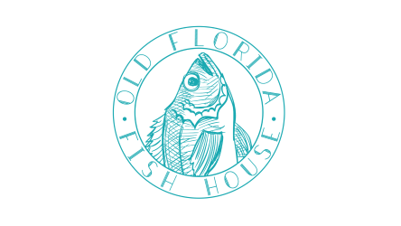
Old Florida Fish House
33 Heron’s Watch Way, Santa Rosa Beach, FL, 32459
www.oldfloridafishhouse.com
850 534-3045
tonyad@oldfloridafishhouse.com
Subject: Recommendation for Gold Diamond Team's Exceptional Service

To Whom it May Concern,

I am writing to provide a glowing recommendation for the exceptional service provided by Gold Diamond team over the past four and a half years. Their team has consistently demonstrated high reliability, professionalism, and exceptional service quality in delivering top-notch cleaning services.

Gold Diamond team's reliability has been outstanding, always showing up on time and completing tasks efficiently. They have proven to be trustworthy and dependable, providing us with peace of mind that our cleaning needs are always taken care of.

Furthermore, the professionalism displayed by their team members has been exemplary. They maintain a high level of professionalism in all interactions with our team and demonstrate respect for our space and property. Their attention to detail and commitment to excellence truly sets them apart.

Overall, the service quality provided by their team has been nothing short of exception. They go above and beyond to ensure that our space is clean and well-maintained, exceeding our expectations every time. Their dedication to delivering high-quality cleaning services is truly commendable.

In conclusion, I highly recommend Gold Diamond team for anyone in need of reliable, professional, and high-quality cleaning services. Their commitment to excellence and exceptional service delivery has made them an indispensable part of our team, and we look forward to continuing our partnership with them in the future.

Sincerely,
Tonya D. Small
General Manager
Old Florida Fish House
850-708-5439

